**CREATING TREEMAPS IN PYTHON**

**Exercise 1**

This tutorial will help you build Treemaps in Python from two different datasets.

You need to install the plotly package in order to create the Treemaps in Anaconda/Jupyter Notebook.

There are two ways of doing this.

Go to Environment and in the “Not Installed” list, search for plotly and click Apply.

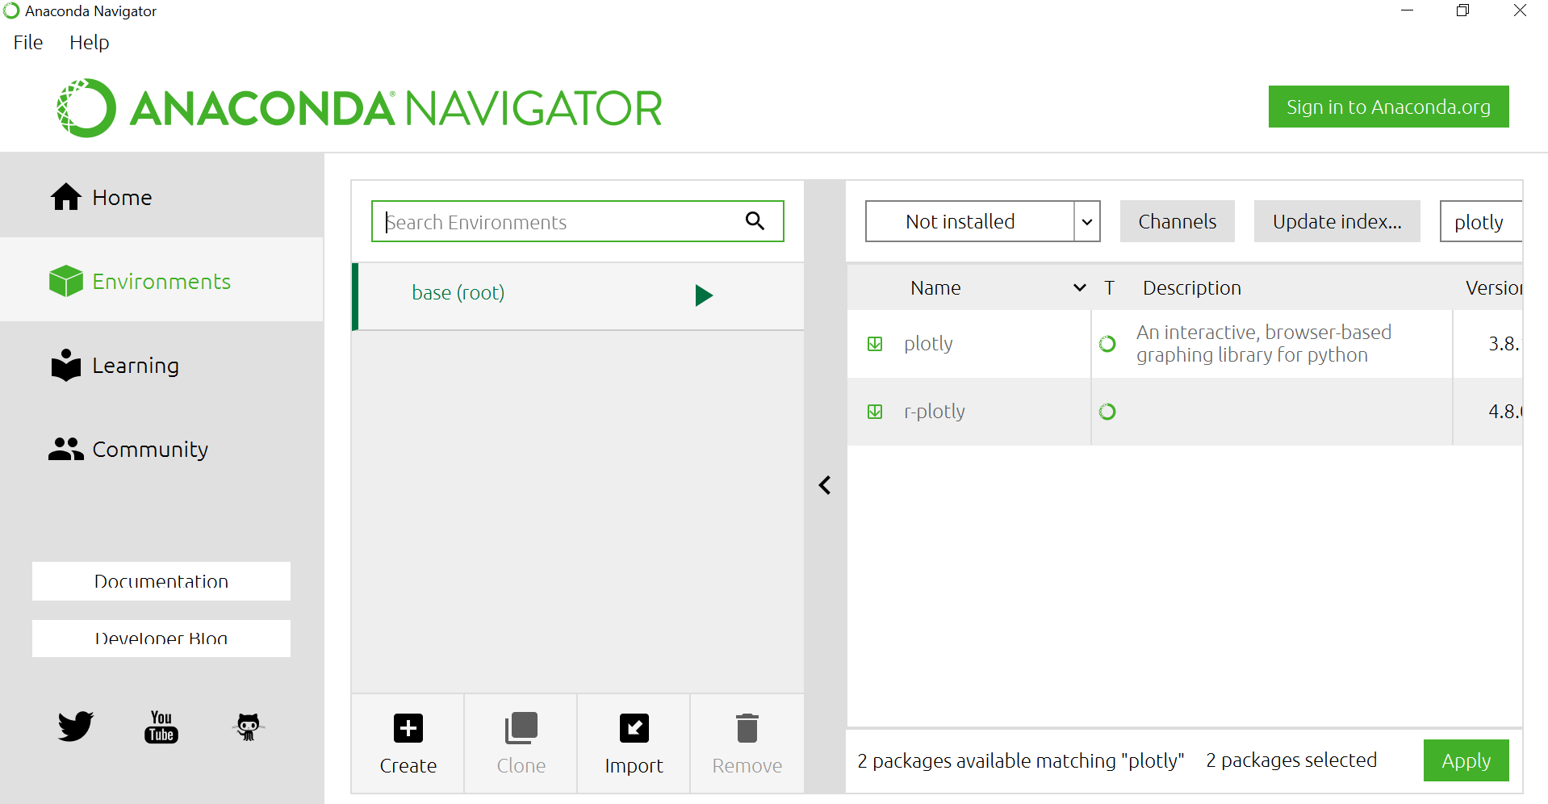

1. If you still cannot install this (sometimes an error might occur), the second way is easy as well. Search for Anaconda PowerShell Prompt and open it.

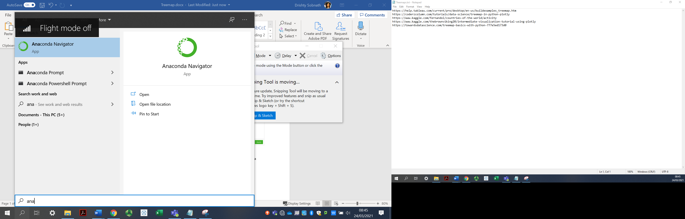

1. This screen will come up.

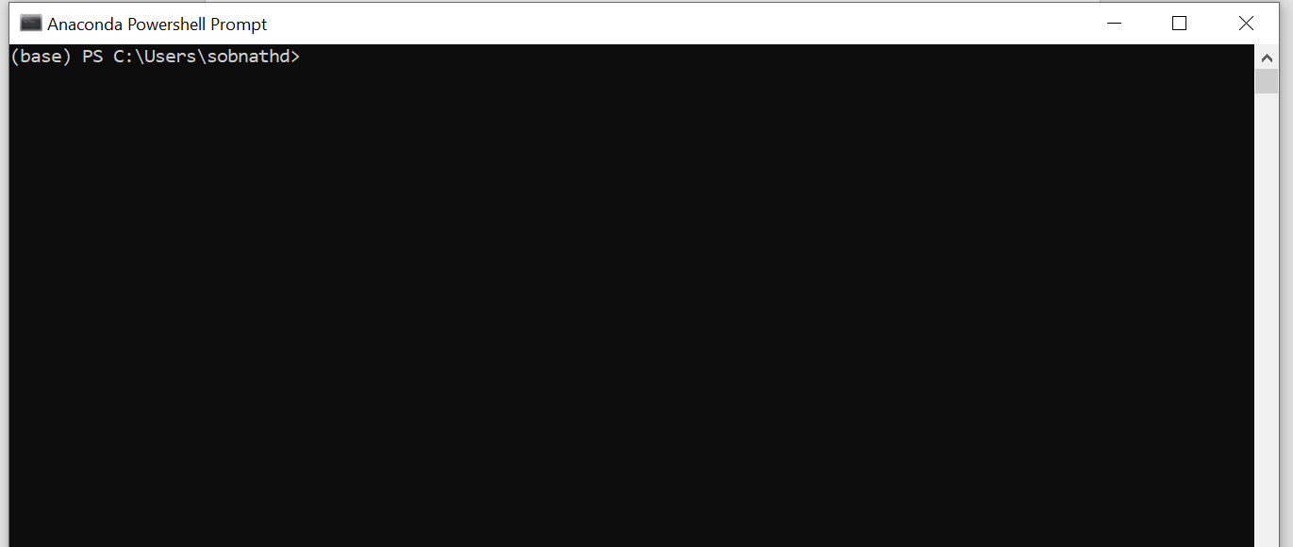

Then just type pip install plotly and the packages will be installed, you can then exit the application as shown.

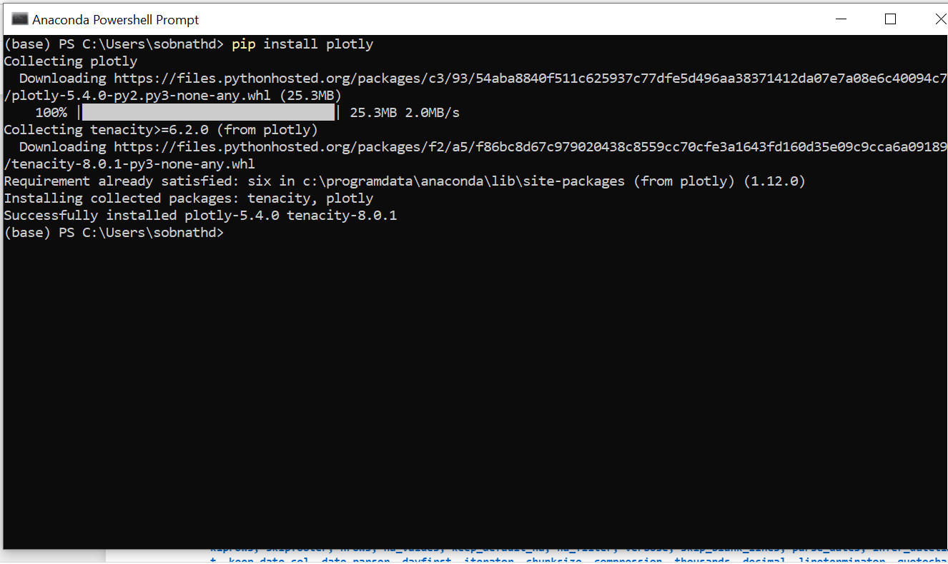

Once you have the necessary packages installed, you can Open Anaconda/Jupyter Notebook and create a new Python file as explained in previous classes.

Treemap charts visualize hierarchical data using nested rectangles. The input data format is the same as for Sunburst Charts and Icicle Charts: the hierarchy is defined by labels (names for px.treemap) and parents attributes.

Plotly is a Python library that is used to design graphs, especially interactive graphs. It can plot various graphs and charts like histogram, barplot, boxplot, spreadplot, and many more. It is mainly used in data analysis as well as financial analysis. plotly is an interactive visualization library. Plotly Express is the easy-to-use, high-level interface to Plotly, which operates on a variety of types of data and produces easy-to-style figures.

With px.treemap, each row of the DataFrame is represented as a sector of the treemap.

Insert the following codes:

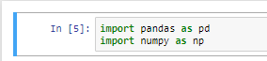

Hit the Run button

Then load your dataset “countries of the world.csv”. This can be downloaded from SOL.

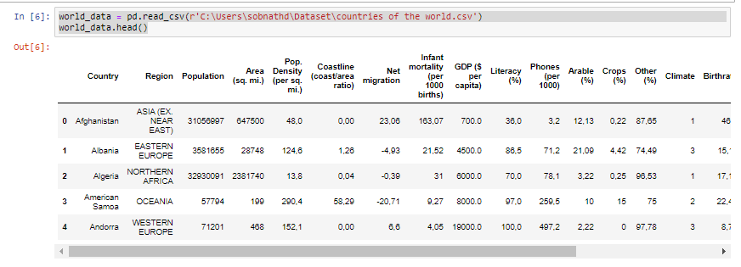

As you have now installed the plotly package, you can now import this. You want to create a Treemap based on the different regions/countries/population and GDP.

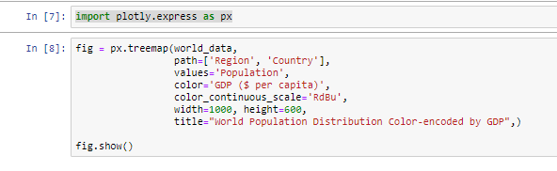

**Parameters:**

**data_frame**: This argument needs to be passed for column names to be used.

**path**: Either names of columns in data_frame, or pandas Series, or array_like objects List of columns names or columns of a rectangular dataframe defining the hierarchy of sectors, from root to leaves.

**values**: Either a name of a column in data_frame, or a pandas Series or array_like object. Values from this column or array_like are used to set values associated to sectors.

**color**: Either a name of a column in data_frame, or a pandas Series or array_like object. Values from this column or array_like are used to assign color to marks.

You can change the colour scheme of your treemap, see more here:

<https://plotly.com/python/builtin-colorscales/#named-builtin-continuous-color-scales>

You have just created your first Treemap in Python.

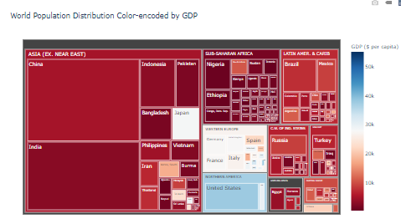

Can you try use another colour scheme based on the link provided?

**Exercise 2**

Let’s do another treemap. This is about video games sales on different platforms. Let’s load the data and explore the different rows/columns. Make sure you change the path to your dataset. The “vgsales.csv” can be found on SOL.

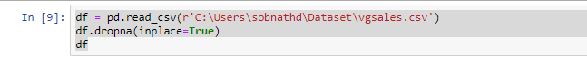

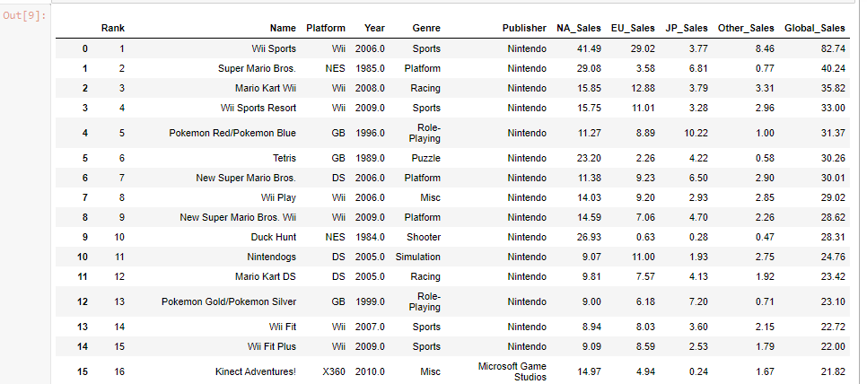

**Your Task**

Plot a treemap using just a few columns as parameters to create the following:

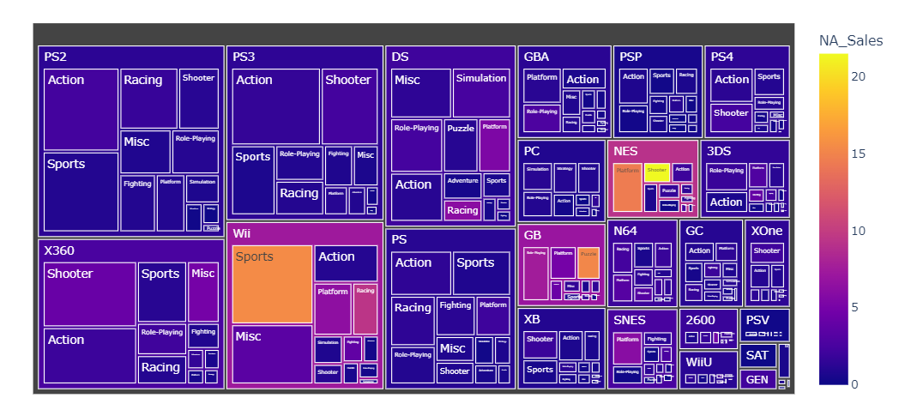

Some additional tutorials on Treemaps in Python:

<https://coderzcolumn.com/tutorials/data-science/treemap-in-python-plotly>

<https://plotly.com/python/treemaps/#set-different-attributes-in-treemap>

**Exercise 3**

**Radar Charts with Python**

Radar chart, also called as Spider chart or Web chart is a graphical method used for comparing multiple quantitative variables. It is a two-dimensional polar visualization.

Download the **Pokemon.csv** from SOL and create a dataframe.

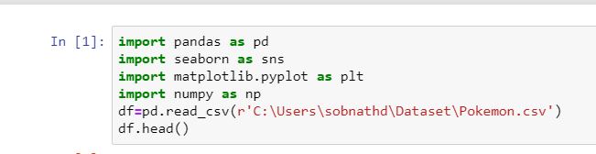

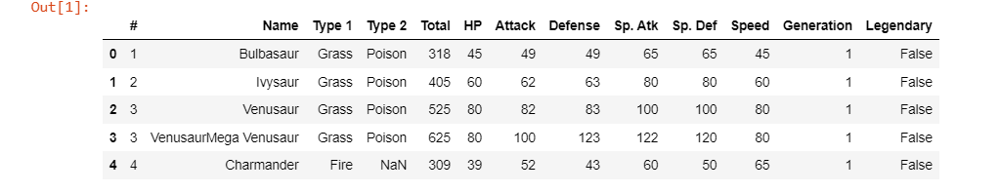

Next we want to create a radar chart showing the Defence, Attack, Sp.Attack Sp.Def and Speed from the CSV file for one Pokemon.

In this example, we are using radar chart to visualize 6 variables. Hence the chart would have 6 polar axes.

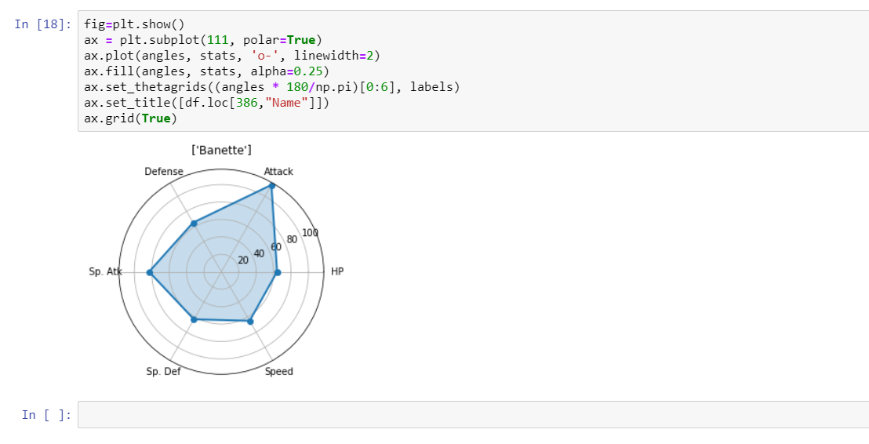

Add these lines.

What does the df.loc[386] means here? Can you find out?

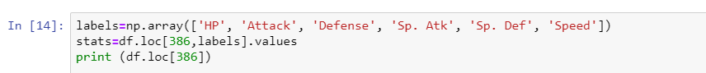

This code snippet is quite generic for radar charts:

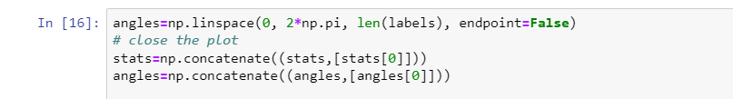

Matplotlib uses the angles in radians for preparing polar plots. We can obtain the angles using linespace function of numpy as below.

Total angle within the circle is 360 degree (2 pi radians). If you want to find out more: <https://www.mathsisfun.com/geometry/radians.html>

1 Radian is about 57.2958

np.linspace(): Create Evenly or Non-Evenly Spaced Arrays

We have obtained the angles for each variable. However, this can generate only four-fifth of a circle, we have to add the first angle at the end of the array to completely describe the circle.

A basic radar chart can be plotted by setting polar=True in add_subplot function. and providing angles and values as argument to plot function.

Plot are can be filled using the fill function providing the angle and values as arguments.

Grid function can be used to show/hide the circular grid. Add these lines and hit Run.

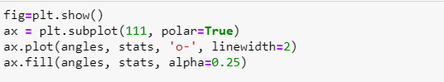

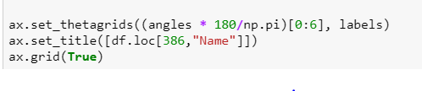

You should get a radar chart like below.



**Your task:**

Now try to add another Pokemon Duskull from the Pokemon.csv file with the same variables on the same figure so that it looks like this:

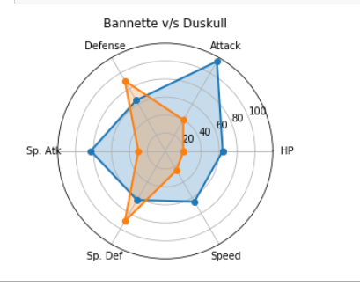

All code snippets for all exercises will be made available on SOL.

More on radar charts here: <https://towardsdatascience.com/how-to-create-a-radar-chart-in-python-36b9ebaa7a64>

**Exercise 4**

Open the Netflix Movies and Guest Stars and load this in a new Python 3 file on Anaconda>Jupyter Notebook. This file is available on SOL. Also download the netflix_data from SOL as you will need it for this exercise.

Run each line of codes and read the documentation. This exercise is guiding you towards some data exploration process. Read the document and generate the scatter plot in different colours.



More exercises:

Go to <https://plotly.com/python/basic-charts/> and create a few different charts in Python based on the examples provided on the website.

More resources here:

<https://coderzcolumn.com/tutorials/data-science/how-to-plot-radar-charts-in-python-plotly>

References

Kaggle: https://www.kaggle.com/alexisbcook/bar-charts-and-heatmaps#Select-a-dataset [accessed 28.05.2021]